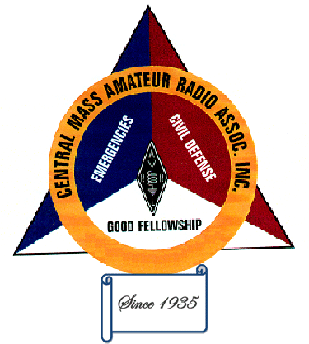
CENTRAL MASSACHUSETTS AMATEUR
RADIO ASSOCIATION, INC
P.O. BOX 60411, WORCESTER, MA 01606-0411

APPLICATION FOR MEMBERSHIP
*Required

Call Sign: _________________ License Class: _______________________
Leave this blank if you do not yet have an amateur radio license.

*Last Name: _______________________ *First (Full) Name: __________________________

Nickname or Shortened First Name, if any: _________________________________________________

*Address with zip code: __________________________________________________________________

______________________________________________________________________________________

*Primary Phone: _______________________ Other Phone (optional): ______________________
Your phone number will only be used for emergency or specific reasons. For example, if you volunteered to help with an even and the
event coordinator needs to call it off, etc.

*Email Address: _______________________________________________________________________
Your email address will be added to our email list. Only our Secretary can send to the email list, which only happens an average
of 2 per week. Please whitelist the email address danrau6+yahoo.com@ccsend.com to ensure you get our emails.

Ham Radio Interests:
Describe any particular interests you have in ham radio. This will help us guide you to the right people in the club that have
similar interest, as well as provide meeting programs that match our membership's interests.

*Are you a member of the ARRL?
Mark only one.

Yes

No

Signature: ________________________________________________ Date: ______________________

How would you like your name to appear on your name tag? (Example: First name or name used on air)

______________________________________________________________________________________

Note: Badges and ID cards can be picked up at any club meeting. If you need to have them mailed, please include an additional $2.00 with your dues.

Dues $25.00 – full membership / $5.00 each additional family member / $20.00 if 65 or older.

